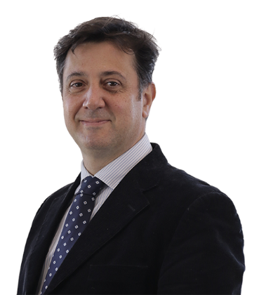
Short bio of Luigi Martirano

Luigi Martirano is a Full Professor of Electrical Power Systems, Faculty of Engineering, University of Rome "Sapienza". He received the M.S. and Ph.D. degrees in Electrical Engineering in 1998 and 2003, University of Rome, Italy. He’s the Coordinator of the PhD School "Engineering and Applied Science for Energy and Industry". Coordinator of the Electrical Area of the Department of Astronautics, Electrical and Energy Engineering (DIAEE). Responsible of the Laboratory of Electric Power Systems and Building Automation of the DIAEE. Secretary of the National Research Group GUSEE - Gruppo Universitario "Sistemi Elettrici per l’Energia".
He has authored more than 260 papers in international journals and conferences. His research activities cover power systems design, planning, safety, protection and coordination, microgrids, smart grids, industrial and commercial power systems, energy communities, renewables, building automation, lighting systems, and energy savings.
Active in the Institute of Electrical and Electronics Engineers IEEE (Student Member since 1998, Member since 2002, Senior Member since 2011). Member at large of the board of Industry Application Society IAS, Vice Chair of IAS Italy Section. Vice President of the IAS - Power Systems Engineering Committee PSEC. Member of the AEIT (Italian Association of Electrical and Electronics Engineers).
Member of the boards of master’s degree programs: Electrical Engineering Degree, Energy Engineering Degree, Safety Engineering Degree and of the Master in Lighting Design MLD. Director of the advanced training course entitled "Management of electrical safety". Teaching activity: - Electric power systems of distribution and utilization; - Microgrids; - Power Systems in Smart Buildings; - Domotics and Building Automation; - Electrical Design in BIM.
He’s an Expert Member of the CEI (Italian Electrical Commission) Technical Committees CT 205 (Home and Building Electronic Systems) and CT3D (BIM in electrical systems). Vice-President of CT 315 (Energy Efficiency). Expert member of the European Technical Committees CENELEC CT 205 “Home and Building Electronic Systems (HBES)”, CEN CENELEC, CEN/CLC/JTC 11 “Accessibility in the built environment”, CEN/CLC/JTC 14 “Energy management, energy audits, energy savings” and CEN/CLC/JTC 15 “Energy Measurement Plan for Organization”.
Associate Editor of IEEE Transactions on Industry Applications, and IEEE Open Journal of Industry Applications.
Founder and partner of the university startup DREAM Domotic Renewable and Energy Management which operates in the field of building automation and smart buildings.

