CURRICULUM VITAE
of
Giovanni Maria Foglia

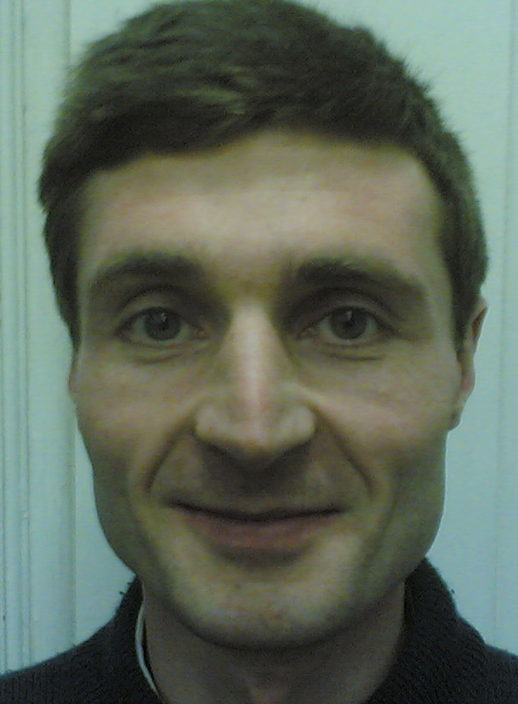 | GianMaria Foglia was born in Busto Arsizio (VA) on 9th June 1971  Department of Energy  Politecnico di Milano, Via La Masa 34, 20156 Milano  +39 02 2399 3746  gianmaria.foglia@polimi.it

Education and experience
- Since December 2019 he has been an Associate Professor in the field of Electrical Machines, Converters and Drives (ING-IND/32). He is with Department of Energy at Politecnico di Milano
- From January 2005to Decembrer 2019 he had been an Assistant Professor in the field of Electrical Machines, Converters and Drives (ING-IND/32). Till 2012 he was with Department of Electrotechnics at Politecnico di Milano, then since 2012 he has been with Department of Energy at Politecnico di Milano
- From February 2001 to December 2004 he had a research grant from Department of Electrotechnics at Politecnico di Milano
- In February 2001 he got the PhD degree in Electrotechnics Engineering at Politecnico di Milano
- In July 1997 he got the Master Thesis degree in Electrotechnics Engineering at Politecnico di Milano
Research activity
- Design and operation of Electrical Machine, in particular Permanent Magnet Machines
- Operation and analysis of reactors and transformers
Teaching activity
- Basic Electrotechnics course
- Electrical Machines course
- Electrical Machines laboratory
- Power Electronic course
Publications
- He is author or co-author of 17 scientific papers published on international journals and more than 40 scientific papers published on proceedings of international conferences; he is co-inventor of an international patent.
- In December 2023, his bibliometric indicators are: : Scopus: h-index = 13 – citations = 654, WOS: h-index = 12 – citations = 456, Google scholar: h-index = 13 – citations = 524
Companies contracts and cooperations
- He cooperated in many contracts with several companies
Peer reviewer activity for international journals and conferences
- He is peer reviewer for about 20 international journals or conferences in electrical engineering field

